**ENVIRONMENTAL MONITORING USING**

**INTERNET OF THINGS(IoT)**

**TEAM MEMBER**

**712221121006- GEERTHANA.P**

**Phase 4 Document Submission**

**Project Title:** Environmental Monitoring

**Phase 3:** Development Part 2

**Topic:** Start building Environmental Monitoring by feature engineering, model training and evaluation

Environmental monitoring using IoT (Internet of Things) involves the collection of data from various sensors and devices to monitor and manage environmental conditions. The data collected can be used for various purposes, such as assessing air quality, monitoring water pollution, tracking climate change, and more. Feature engineering, model training, and evaluation are essential steps in building effective environmental monitoring systems using IoT. Here's a step-by-step guide:

1. Data Collection and Preprocessing:-

- Deploy IoT sensors and devices to collect data. These sensors can include temperature sensors, humidity sensors, air quality sensors, water quality sensors, and more.

- Ensure the data collected is accurate and reliable. Quality assurance and calibration of sensors may be necessary.

- Data preprocessing involves cleaning, handling missing values, and dealing with outliers. This step is crucial to ensure the data's quality.

2. Feature Engineering:-

- Feature engineering is the process of creating relevant and informative features from the raw sensor data. It helps improve the model's performance.

- Domain knowledge is critical in this step. Consider expert advice or research to determine which features are relevant to your environmental monitoring goals.

- Feature extraction and selection techniques can be applied to transform and choose the most meaningful features.

3. Data Splitting:-

- Divide the data into training, validation, and test sets. Common splits are 70% for training, 15% for validation, and 15% for testing.

- Ensure that the data is split temporally to prevent data leakage.

4. Model Selection:-

- Choose a machine learning or deep learning model appropriate for the environmental monitoring task. Common models include decision trees, random forests, support vector machines, neural networks, and more.

- Consider the model's ability to handle time-series data if your data is sequential.

5. Model Training:-

- Train the selected model on the training data. During training, the model learns the underlying patterns in the data.

- Optimize hyperparameters to improve model performance through techniques like cross-validation.

6. Model Evaluation:-

- Evaluate the model's performance on the validation set using appropriate metrics for your task. Common metrics for environmental monitoring include Mean Absolute Error (MAE), Mean Squared Error (MSE), or domain-specific metrics.

- Plot relevant graphs or visualizations to better understand the model's predictions and performance.

7. Model Fine-Tuning:-

- Adjust the model as needed based on the evaluation results. This may involve changing hyperparameters, adjusting the model architecture, or trying different algorithms.

8. Testing and Deployment:-

- Once satisfied with the model's performance, test it on the held-out test set to assess its generalization capabilities.

- Deploy the model in your IoT system for real-time monitoring and decision-making.

9. Continuous Monitoring and Maintenance:-

- Monitor the model's performance over time, as environmental conditions can change.

- Retrain the model periodically with new data to adapt to changing conditions.

10. Ethical Considerations:-

- Be mindful of privacy and security concerns when collecting and using environmental data.

- Consider the ethical implications of your monitoring system, especially when dealing with sensitive environmental data.

Remember that environmental monitoring with IoT is an ongoing process that requires continuous improvement and adaptation to changing conditions and data sources.

**Evaluation of Environmental Monitoring Systems:-**

The main purpose of this research paper is to advance research towards a framework for evaluating IoT environmental monitoring systems. Such systems are typically based on some form of the IT Service-Oriented Architecture (SOA) model, with common versions (at different levels of abstraction) being wireless sensor networks (WSN) and the (five-layer version of) IoT-Architecture (IoT-A) [6]. For IoT systems to be successful, they need to be viable, versatile, and modifiable, and for this reason IoT designs need to meet scalability, interoperability, distributed network, resource minimization and security requirements [8]. At the conceptual stage of the system development life cycle, an evaluation of alternative design models is performed so as to satisfy any stakeholder concerns about the quality and future potential of their system. This is recommended by BS ISO/IEC 42030 (ISO 42030) [33], which is specifically published to help with IT architecture evaluations [34]. Such evaluations aim to answer the questions of “what the system does'' and “how well it does it”, answers which involve value assessments as well as fact finding [34]. ISO 42030 requires that an architecture evaluation framework consists of a two-pass process [11] in order to facilitate better control for qualities which are irrelevant or redundant. Thus, the analysts performing the assessment will need to firstly eliminate proposals that do not satisfy mandatory non-functional requirements (NFRs identified from ISO 25010), and secondly, critically compare the proposed systems [11]. To do this, business value drivers (e.g., costs, resource consumption, time use, risk factors) will need to be sourced from relevant analytical, statistical and system audit records [34].

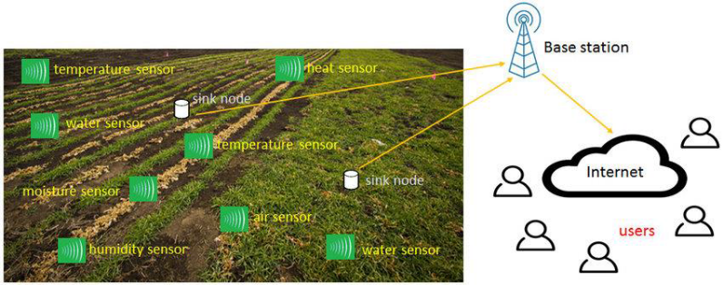

**Elimination of Redundant -Ilities (Step 1)**

The aim of Steps 1 is to ensure that only the required -ilities are included during the evaluation at Step 2. Fig. 1: Step 1 of the Environmental Monitoring Evaluation. The conclusion of the first pass evaluation (Step 1), is followed by the evaluation of the factors that correspond with the specific evaluation objectives. This is the second pass of the evaluation process in ISO 42030 [33] and is referred to in this paper as Step 2. This entire process is represented diagrammatically.

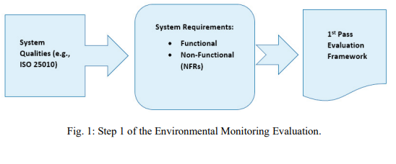

**Evaluation Approaches, Methods, and Analysis (Step 2)**

The process of architecture evaluation at Step 2 involves the selection of evaluation objectives for the Architecture Evaluation Approach (AEA) which will help to form the evaluation strategy [33]. The AEA is used to conceptualize a desired IT architecture. This is done in terms of mapping its key characteristics, properties, knowledge as well as the capabilities of current permutations of the system [34]. Evaluation approaches can include models, simulations, prototype demonstration, technical analysis, expert panel, and independent audit [34]. Smart environmental monitoring approaches could include air quality data analytics [35], AI waterbody models [36] and WSN prototypes [37].

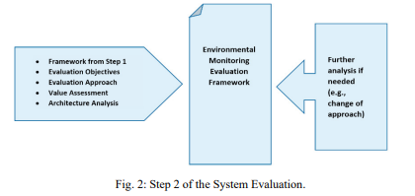

This analysis will show the preferable options for stakeholders. Where this is not the case or more information is needed, additional analysis using other evaluation approaches from ISO 42030 may have to be performed [34]. The choice of the evaluation approach should be driven by selected evaluation objectives. These may be fundamental objectives which aim at answering the question of “what the system does” or means objectives which serve to benchmark “how well the system fulfills its mission”. Attention to the type and substance of evaluation objectives plays an important part in producing valuable assessments.

**A Model Environmental Monitoring Framework**

In the context of the envisaged environmental monitoring framework, therefore, the evaluation objectives are the key NFR which were identified for these variants of IT architectures. In this framework these objectives are Reliability, Functional Suitability, Maintainability, Security, and Usability. The Architecture Evaluation Approach (AEA) uses these objectives to investigate a proposed architecture’s suitability as an IoT environmental monitoring solution.

Thus, for example, to perform the evaluation for these qualities the following objectives could be used:

• IoT environmental sensor systems should possess a constant rate of resource utilization.

• ‘Smart’ sensors should gather environmental data accurately.

• Such-and-such a system needs to support different communication modules.

• Expected rates of breach of access and confidentiality in our network need to be low.

• The user interface should be attractive to users (sensor data should be easy to find and navigate).

These objectives can be used to evaluate the monitoring system by balancing the socio-political factors relevant to aspects of the architecture which impact on the community and society. Noran & Bernus [11] suggest the PESTEL Model (political, economic, social, technological, environmental, and legal dimensions) for this external factor analysis. Additionally, systems need to meet relevant regulatory requirements (e.g., communication protocols, sensor certification, etc.) to satisfy respective stakeholders. The process and results of this evaluation need to be documented for use in future decision-making and analysis.